Garage Remote Control Programming Instruction

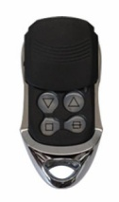
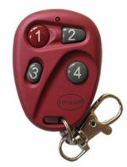
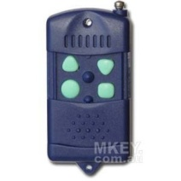
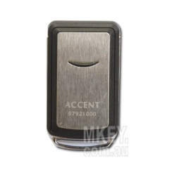
Forza Silver/Blue/1000/2000

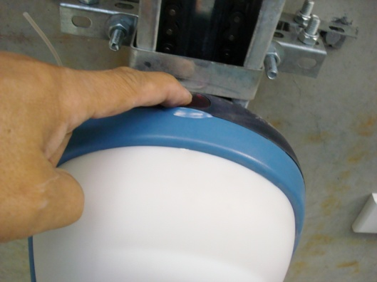
Step 1: Open the cover of Forza opener by pressing the dark red button on the door opener unit
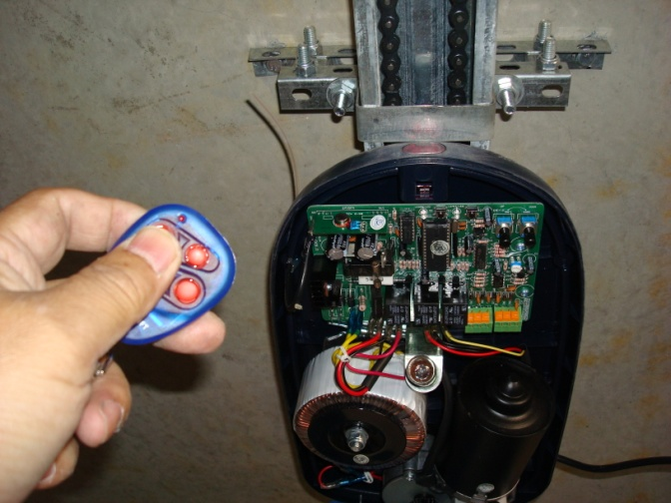
Step 2: Inside the opener, you will see the receiver board, press and release S1/LEARN (program) button on the board Red LED will be on
Step 3: Then press any desired button on the new remote for 1 second then release Red LED will start flashing then extinguish
Step 4: Programming is complete. Press the button to test whether it works If no success, repeat the above step 2&3.

► If you use the remote to operate main entry gate/door of block of unit/apartment:
- you will first need to locate the receiver box (left picture below) which is usually attached to the motor (middle picture)
- the S1 (program) button is on the circuit board inside (right picture)
- following the above step 2&3 to program the new remote

