Installation Instruction of Upgrade Receiver Kit

B&D MPC101/102/103

NOTE: Disconnect electric power to the opener before removing covers.

Step 1: Cut away the section at the top of the B&D MPC1 Wall Control to expose the J2 connector (see the left picture below)
Step 2: Plug the two-wire connector of the add-on receiver into J2 connector ( please ensure the correct direction, i.e. the two wires are at the right hand side when facing the wall control box. See middle picture below)
Step 3: Restore power to the opener and connect the power pack of the add-on receiver to power point
Step 4: Press the button on the pre-programmed remote coming with the receiver to test.

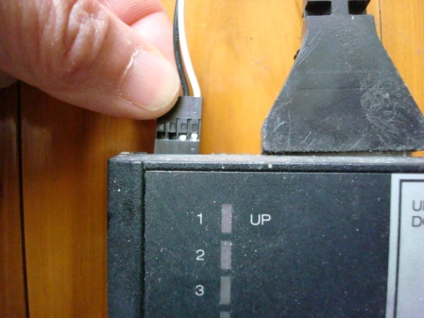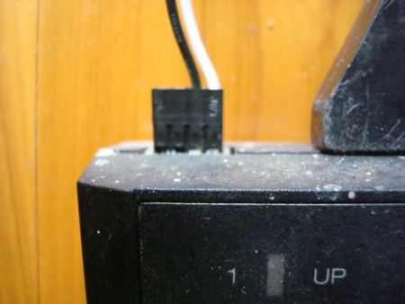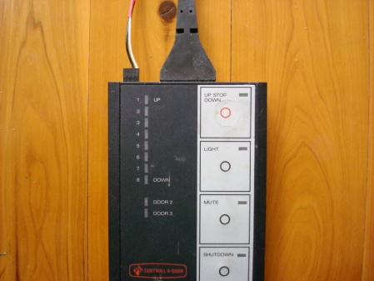

J2

