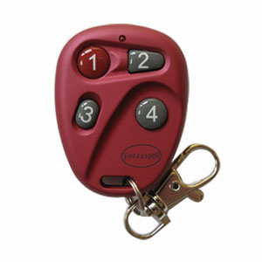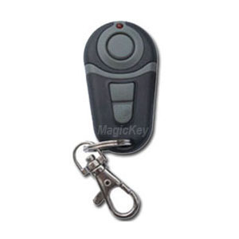

Thank you for purchasing from us. Forza1000 remote has been replaced by forza1000R.

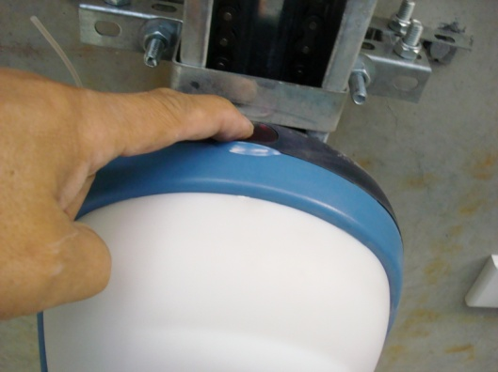

Please follow the steps below with the reference of the photos left to do the program for MK700.

1. You need to open Forza opener by pushing the dark red button on the door opener unit.
2. Inside the opener, you can see a receiver board, press S1(program) button on the board once.
3. Then press one of buttons of the new remote (any button) twice.
4. Now you can test if works. Then put the cover back.

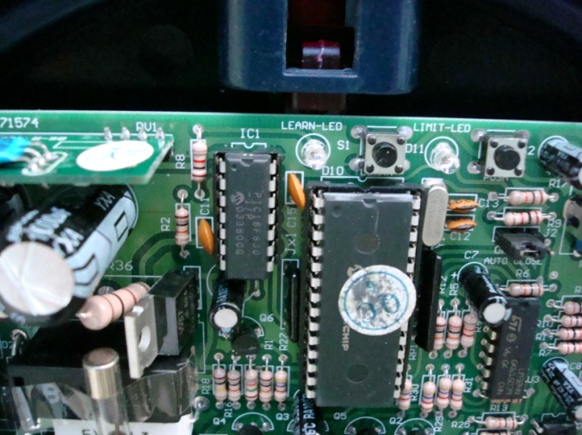

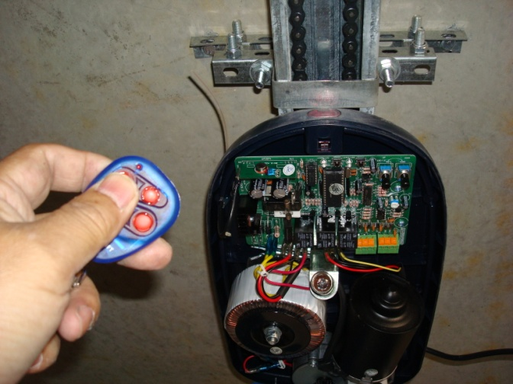

For **main entry door** of a block unit, the S1 (program) button is usually located in the stand along receiver ( it can be found near the drive unit), as the picture shown below:

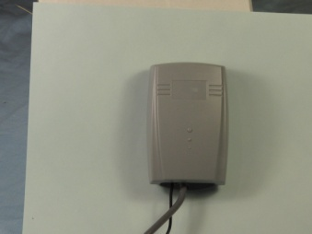 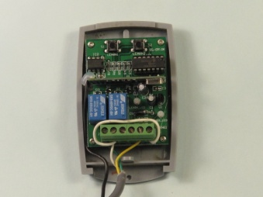

As the arrow pointing, the S1 (program) button is inside the receiver, then you can do the programming.