MK702GA -replacement for GALAXY remotes

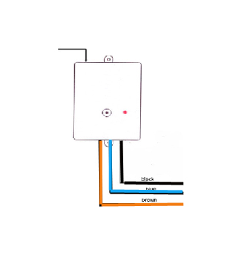
Antenna

The receiver goes to terminals 2 (Wall Control), 5 (GND), 6 (+24V).
Connection Guide for Dominator Garage Door Auto Opener
- Switch power off
- Connect black wire to 2
Connect blue wire to 5
Connect brown wire to 6
- Switch power on and the LED will be illuminating
- You can test to operate your the garage door now.
- If not works swap 2 and 5 connection. black wire to 5, blue wire to 2
Storing Transmitter Coding (Note: This unit has been pre-coded before send for quality test purpose)
- Press LEARN button on Receiver once, the Signal LED will be illuminated.
- Press one button of the transmitter you wish to open the door, Signal LED will be off
- Press the same button of the remote again, LED will be flashing
When the LED stops flashing, the coding sequence is complete.
Delete coding
Press and hold LEARN button about 10-20 seconds until LED of the receiver illuminates, All codes are removed.

www.mkey.com.au

